Tab 1

WEST JET VACATIONS

https://www.westjettravelagents.com/

1. Booking & Manage my Booking
2. Groups
3. BDM Contact & Client Complaint/Flight delay Compensation
4. Travel Agent Helpful Links
5. **1) Booking & MANAGE MY BOOKING**
6. **\*Bookings can be made via Galileo Vacations,** [**Westjet Vacations**](https://web.sax.softvoyage.com/) **or by calling the WestJet Call Centre.**
7. **Be sure to quote the** [**West Jet Travel Protection Plan**](https://www.westjettravelagents.com/app/uploads/2024/03/TPP-as-of-March-20-2024-for-bookings-April-1-2024-1.pdf?language=en) **during the selling process. It can only be added at the time of booking.**

**ONCE A BOOKING HAS BEEN MADE** - Below is an example of what to send to your clients after they make a WestJet Vacations booking with you. You can find their airline PNR on the WestJet vacations invoice. If they are traveling with kids ages 13 & under, you can also use this PNR to pre-select complimentary family seating for them on the flights under [Manage Flights](https://www.westjet.com/en-ca/manage/).

**Hi**

**Your trip is booked and I have sent a copy of your invoice. Please be sure to check your spam folder.**

**Your edocuments will be ready and sent to you once the final payment has been made but I wanted to go over a few housekeeping items.**

**With WestJet Vacations everyone is entitled to a carry-on but Checked bags & advanced seat selection will incur additional fees. It is less expensive to pay it in advance. If you wish to add prepaid baggage or add seats to your booking you can follow the steps below.**

**1)** [**www.WestJet.com**](http://www.westjet.com/) **or** [**https://www.westjet.com/en-ca/manage/mobile-app**](https://www.westjet.com/en-ca/manage/mobile-app)

**2) Manage Trips**

**3) Manage Flights**

**4) enter Reservation Code :**

**5) Once logged in, click on edit trip to add bags & seats**

**Please also download the West Jet app and track flight changes as well as to view movies, TV shows etc during the flights on your devices.**

[**https://www.westjet.com/en-ca/manage/mobile-app**](https://www.westjet.com/en-ca/manage/mobile-app)

**Please let me know if you have any questions along the way.**

* Edocs will be ready almost immediately after final payment has been made on the booking.

They can be accessed either through TripBook on Galileo or under [Manage Vacations Tab](https://www.westjet.com/en-ca/manage/vacations) on WestJet.com

Please read through them very carefully to ensure spellings are correct and booking details are correct before sending them out. I prefer to email myself a copy and then add more details to the body of the email about the check in process, transfers, hotel check in etc.

* Make sure to adjust country entry requirements, departure tax info, tourist visa according to the destination your clients are traveling to.

1. **2) GROUPS - All group quotes must be vetted by management before proposal sent to clients**
2. **https://www.westjettravelagents.com/westjet-vacations-groups/**
3. WJV requires a minimum of 5 rooms/10 paying guests to constitute a group.
4. Instant Group quote Tool
5. * Enter Guest lead name, Group type and number of guests
6. * Destination, departure city, departure & return date, more detail number of guests

* Get the Quote

*Group quotes are always net (you must add commission before quoting the per person price to guests).

* Always check promotions such as Tax promo & booking deadlines before sending the quote to your clients.

* TC’s Please check with Management to discuss how to offer these to clients

* Final payments - These are usually due 60 days prior to departure (be sure to check this). It is crucial to advise guests that finals are due 70 days prior to departure. This allows a buffer in case there is an issue with payment from some of the guests.

*Questions, please contact your coordinator (email will be on quote ) or reach out to groupvacations@westjet.com*

**Once Group lead has closed :**

**\*** Go over invoice and contract closely before signing and sending back to your assigned coordinator

* Booking can be accessed under Manage Booking using group booking number.

*To view the entire group manifest use booking number as password or leave this blank if only trying to access one room at a time

* Guests names/birthdates can be added via the agent portal

* Deposits, payments along the way, final payments can all be applied via agent portal or revnet (in galileo)

* Make sure to always go over the invoicing from your WJV Group Coordinator to ensure no major issues arise along the way.

* Once final payment has been made, please review invoice and correct any discrepancies

* Edocs are issued 28 days prior to departure. Please reach out to your coordinator to request release if necessary

* Send each room individually to avoid confusion

**3)** [**BDM CONTACT**](https://vacations.aircanada.com/en/dam/jcr:bc88ca1f-46de-42a9-bd08-c23590c13e91/Our-Sales-Team-2024-EN.pdf) **& WJV Customer Assistance**

Shane Dineen :672 965-9690

shane.dineen@westjet.com

Business Development Manager

TRAVELSAVERS : Priority line for reservations : 1-844-260-7424

Every agent has their own login. Lindsay is admin

604-574-1991 Accounting: taaccounting@westjetvacations.com

tapaymentservices@westjet.com

agencysalesrep@westjet.com (if we have no designated rep)

**5) Travel Agent Helpful Links**

<https://www.westjettravelagents.com/westjet-vacations/>

## **Agent self-serve tools**

Effective April 24, 2024, a service fee will apply when contacting the Travel Support Team for any WestJet Vacations requests that could have been completed using a self-serve option.

* A non-refundable fee of $25 plus GST per paying guest will apply if the Travel Support Team creates a WestJet Vacations booking that could have been made using a booking channel.
* For post-booking requests, a non-refundable fee of $25 plus GST per booking will apply for requests that can be self-managed.

Full details can be found [here](https://www.westjettravelagents.com/westjet-vacations-self-serve-admin-fee/).

Live Chat :<https://www.westjettravelagents.com/westjet-vacations-live-agent-chat/>

We encourage you to visit our learning module, which will help familiarize you with all the self-serve options available for WestJet Vacations bookings:

[**LEARNING MODULE**](https://rise.articulate.com/share/L66iuDAFi04yNR1kMLAkK1xYyxhe_wM6)

1. **To help you manage your clients’ WestJet Vacations packages, this chart outlines which requests can be self-served and where to go to complete the request.**
2. 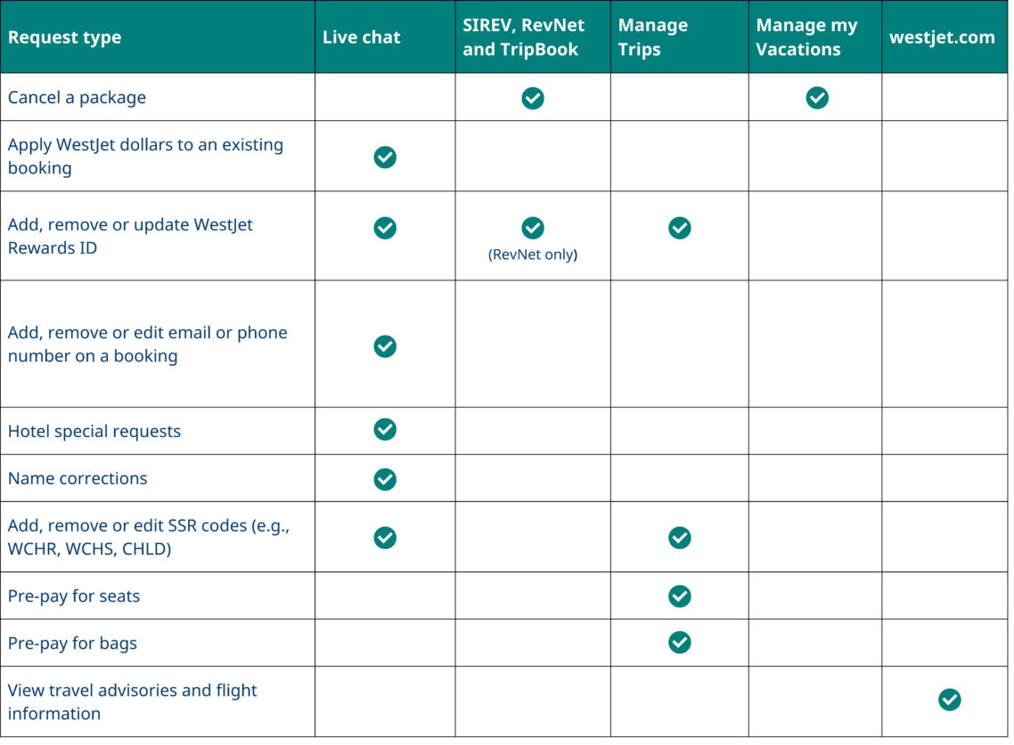

Tab 2